Refer to the KPIs for the Tech-and-GO! project category that your agency is applying for:
IT Solution Projects | Ctrl + Click here for the relevant Start, Go and Grow IT Solution Project KPIs.
Pre-Scoped Project Consultancy | Ctrl + Click here for the relevant Pre-Scoped Project Consultancy KPIs.  Pre-Scoped Consultancy Services include:  - Digital Strategy Planning (DSP)  - Data Management Consultancy (DM)  - IT Solutions Consultancy:  - Start Consultancy  - Go Consultancy  - Grow Consultancy  - Digital Implementation Consultancy (DIC)  - Consultancy Support Service (CSS)  - IT Project Coaching (IPC)
IT Audit, Cyber Security, and Data Protection Consultancy | Ctrl + Click here for the relevant IT Audit, Cyber Security (CS), and Data Protection (DP) KPIs.
Robotic Process Automation and Digital Marketing Consultancy | Ctrl + Click here for the relevant Robotic Process Automation (RPA) and Digital Marketing KPIs.
IT Professional Services  Non Pre-Scoped Project Consultancy | Ctrl + Click here for the relevant KPIs.  Ctrl + Click here for the relevant Non Pre-Scoped Project Consultancy KPIs.

FOR IT SOLUTION Projects
Agencies are required to fulfil the following Output KPIs for each IT Solution project:
- Productivity gain (20%)
- Staff / client satisfaction (70%)
- [Only for Go Digital or Grow Digital]: Return of Investment (ROI) / Breakeven Year (Project costs to breakeven within 4 years)

Fill in the KPI table in the Proposal section of your application on OurSG Grants Portal according to the following example:
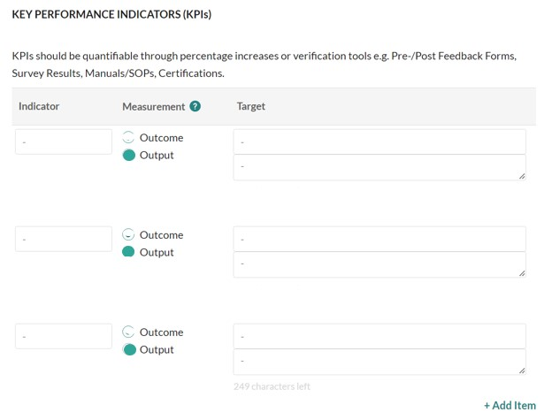
Productivity Gain:
Time saved after system/ solution implementation
Describe the tool used to track this indicator e.g.,
Comparison of time taken between pre and post implementation OR Pre and post implementation reports to capture time savings.
Describe the tool used to track this indicator e.g.,
Staff [OR Client] feedback surveys to capture satisfaction rating related to the system/solution implementation.

Within 4 years [Actual figure is not required.]
Total Project Cost / Estimated Cost Savings
[Actual figures are not required.]
[Specify only ONE]

Staff [OR Client] satisfaction related to the system/solution implementation

[Only for Go Digital or Grow Digital]
Return on Investment (ROI) / Breakeven Year
xx %
xx %

for pre-scoped project consultancy
Agencies and contractors are required to fulfil the following KPIs for each consultancy project:
- Staff satisfaction with consultancy service (70%)
- Adherence to project timeline (100%)
Fill in the KPI table in the Proposal section of your application on OurSG Grants Portal according to the following:
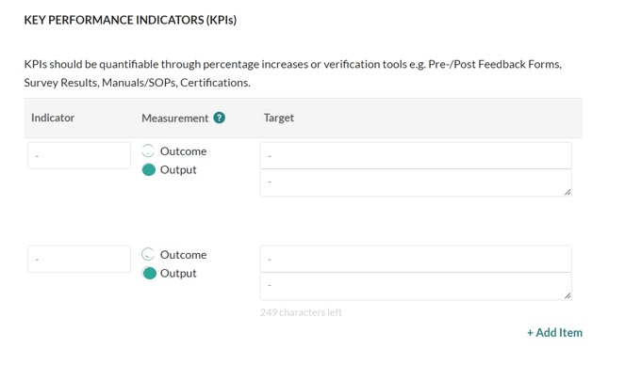
Scope of Works (SOW)
Final consultancy Report
Consultant Evaluation Survey
xx %
xx %
% Adherence to project timeline as stipulated in Scope of Works, unless otherwise agreed by NCSS
Staff satisfaction with consultancy service

THINGS TO NOTE
For the following consultancy services related to IT Solution(s) adoption, agencies are required to fulfil the below additional KPIs:
Agencies should note the below but are not required to fill the additional KPIs in the KPI table in the Proposal section on your application on OurSG Grants Portal.
Consultancy Service | Additional KPIs
- Go Consultancy  - Grow Consultancy  - Digital Implementation Consultancy (DIC)  - IT Project Coaching (IPC) | - Productivity gain (20% increase)  - Staff / client satisfaction related to IT solution(s) implementation (70%)  - Return on Investment (ROI) / Breakeven Year (Project costs to breakeven within 4 years)

for it Audit, CS, and DP consultancy
Agencies and contractors are required to fulfil the following KPIs for each consultancy project:
- Staff satisfaction with consultancy service (70%)
- Adherence to project timeline (100%)
Fill in the KPI table in the Proposal section of your application on OurSG Grants Portal according to the following:
Final Consultancy Report
Consultant Evaluation Survey
xx %
xx %
% Adherence to project timeline as stipulated in Project Addendum, unless otherwise agreed by NCSS
Staff satisfaction with consultancy service

for RPA AND DIGITAL MARKETING consultancy
Agencies and contractors are required to fulfil the following KPIs for each consultancy project:
- Staff satisfaction with consultancy service (70%)
- Adherence to project timeline (100%)
Fill in the KPI table in the Proposal section of your application on OurSG Grants Portal according to the following:
Scope of Works (SOW)
Final consultancy Report
Consultant Evaluation Survey
xx %
xx %
% Adherence to project timeline as stipulated in Scope of Works, unless otherwise agreed by NCSS
Staff satisfaction with consultancy service

for IT Professional services
Agencies and contractors are required to fulfil the following KPIs for each consultancy project:
- Staff satisfaction with service (70%)
- Adherence to project timeline (100%)
Fill in the KPI table in the Proposal section of your application on OurSG Grants Portal according to the following:
Scope of Works (SOW)
Final Report from Service Provider
Consultant Evaluation Survey
xx %
xx %
% Adherence to project timeline as stipulated in Scope of Works, unless otherwise agreed by NCSS
Staff satisfaction with consultancy service

THINGS TO NOTE
If the IT Professional Service is related to IT Solution(s) adoption, agencies are required to fulfil the below additional KPIs:
Agencies should note the additional KPIs but are not required to fill these into the KPI table in the Proposal section on your application on OurSG Grants Portal.
- Productivity gain (20% increase)
- Staff / client satisfaction related to IT solution(s) implementation (70%)
- Return on Investment (ROI) / Breakeven Year (Project costs to breakeven within 4 years)

for NON pre-scoped project consultancy
Agencies and contractors are required to fulfil the following KPIs for each consultancy project:
- Staff satisfaction with consultancy service (70%)
- Adherence to project timeline (100%)

Fill in the KPI table in the Proposal section of your application on OurSG Grants Portal according to the following:
Consultant Evaluation Survey
% Adherence to project timeline as stipulated in Scope of Works, unless otherwise agreed by NCSS
xx %
Scope of Works (SOW)
Final consultancy Report
xx %
Staff satisfaction with consultancy service

THINGS TO NOTE
For consultancy projects related to IT Solution(s) adoption, agencies are required to fulfil the below additional KPIs:
Agencies should note the additional KPIs but are not required to fill these into the KPI table in the Proposal section on your application on OurSG Grants Portal.
- Productivity gain (20% increase)
- Staff / client satisfaction related to IT solution(s) implementation (70%)
- Return on Investment (ROI) / Breakeven Year (Project costs to breakeven within 4 years)

