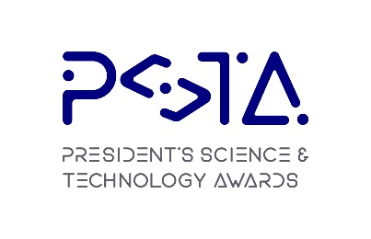
PRESIDENT’S SCIENCE AND TECHNOLOGY AWARD
(PSTA)
2024
NOMINATION FORM
FOR PRESIDENT’S SCIENCE AND TECHNOLOGY MEDAL (PSTM)
The PSTM recognises individual accomplishments and contributions that have significantly advanced Singapore’s development through promotion and management of S&T. The accomplishments and contributions would generally be acknowledged by the S&T ecosystem as having a significant impact on the ecosystem’s capabilities or international stature. The PSTM is not meant to recognise research accomplishments or contributions to advancing individual technologies, as these are covered by the PSA and PTA, respectively. Examples of achievements recognised by the PSTM include, but are not restricted to:

- Being the driving force in pioneering the establishment of an important field of study in Singapore.
- Being the leader who was instrumental in the raising of an S&T institution to world-class status.
- Contributing exceptionally to a major levelling-up of our S&T ecosystem’s capabilities or international stature.

Section A: Biographical Data

A.1: Nominee’s particulars
Please append the nominee’s CV with this nomination.
Title:
Name:
Designation:
Organisation:
Contact No:
Email:

A.2: Nominator’s particulars

Title:
Name:
Designation:
Organisation:
Contact No:
Email:

Section B: Nominee’s Contribution in Science & Technology (S&T)

Describe how the nominee has made distinguished, sustained and exceptional contributions and played a strategic role in the development of Singapore through the promotion and management of S&T.

Please address points B.1, B.2 and B.3 where appropriate and include other notable aspects of the nominee’s work towards the development of Singapore through the promotion and management of S&T.

(B.1) Contribution and impact of the Nominee’s work resulting in significant scientific, technological or economic benefits in Singapore (e.g. enhancement of national competitiveness in the industrial or services sectors, capacity building, attraction of new S&T projects to Singapore and growth of new clusters of technological competencies, commercialization drives and outcomes, economic value-add of contributions, advocacy for new S&T developments or directions, etc.).

(B.2) Contribution and impact of the Nominee’s leadership and management in the S&T ecosystem in Singapore.

(B.3) Contribution and impact of the Nominee’s work towards enhancing the reputation and strengths of Singapore as a world-class international S&T hub.

Section C: Nominator’s Declaration

By submitting this form, I hereby consent to provide NRF information which may include personal data as defined in the Personal Data Protection Act 2012, for the purpose of use in the PSTA evaluation, selection process and other administrative purposes, in accordance with the privacy statement set out in https://www.psta.gov.sg/privacy/

By submitting this form, I hereby agree with the PSTA Terms of Participation set out in https://www.psta.gov.sg/terms-of-use/

SIGNED by

_______________________________________

Nominator’s Name & Designation
Date

- End of Nomination Form -

