Parent/ Legal Guardian’s eFAS User Journey

This section covers the steps that the parent/ legal guardian will have to follow when he applies for MOE FAS through the eFAS form.

- Parent/ Legal guardian will be brought to the eFAS login page upon clicking on the eFAS link.

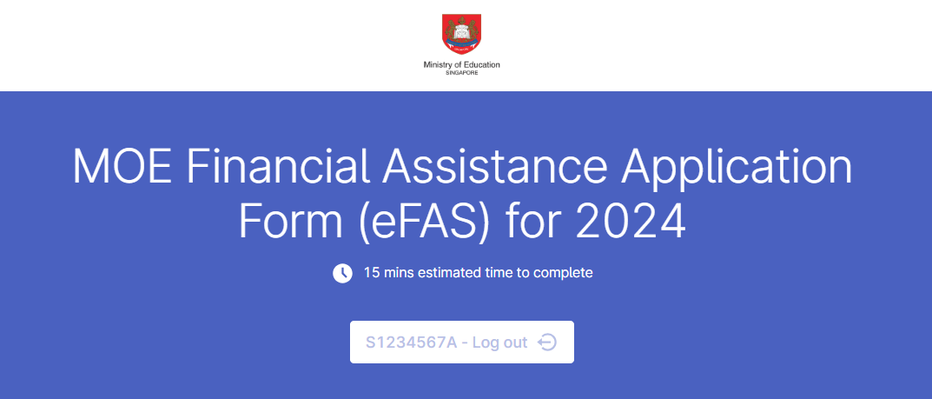

- Parent/ Legal guardian will need to login with Singpass and FormSG will prefill the following information taken from MyInfo. From Oct 2023, records of children below the age of 21 years old are also available.

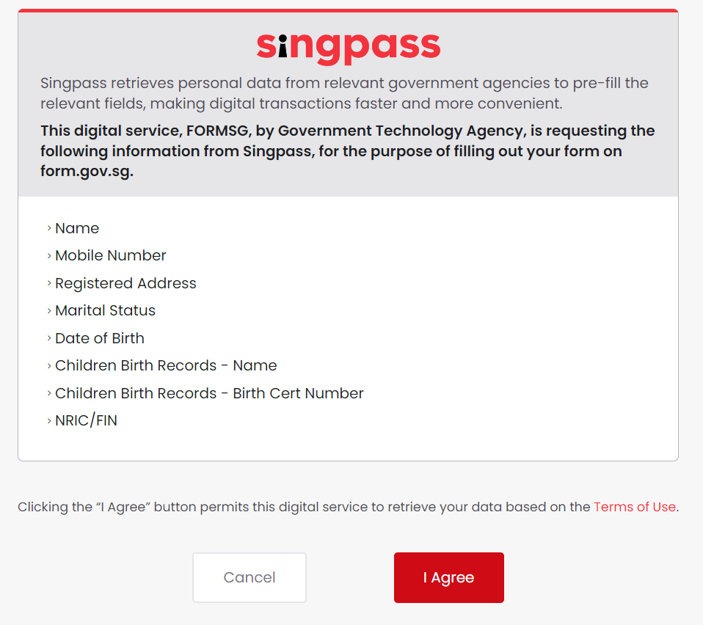

- Instructions and required softcopy supporting documents are clearly listed at the start of the eFAS form.

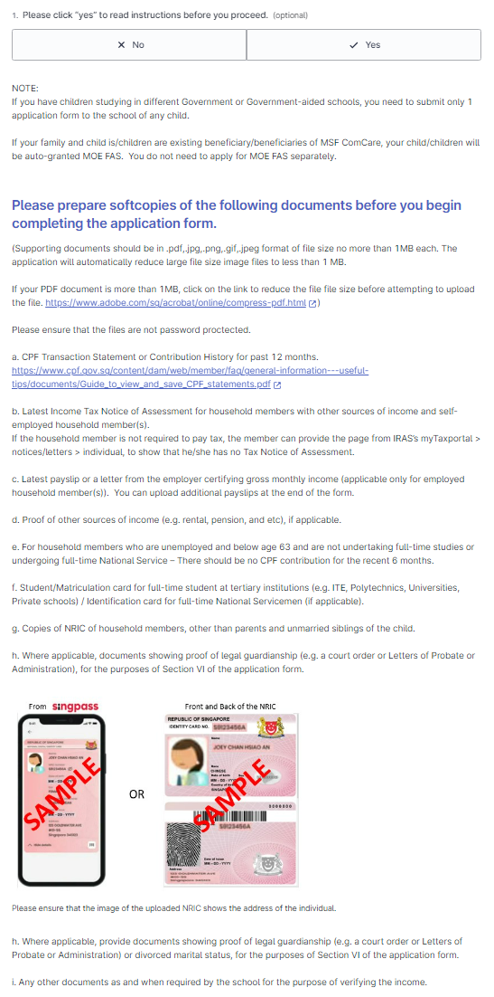

- Parent/ Legal guardian can select the child/ward from a drop list. The name and UIN of the child will be populated in the form.

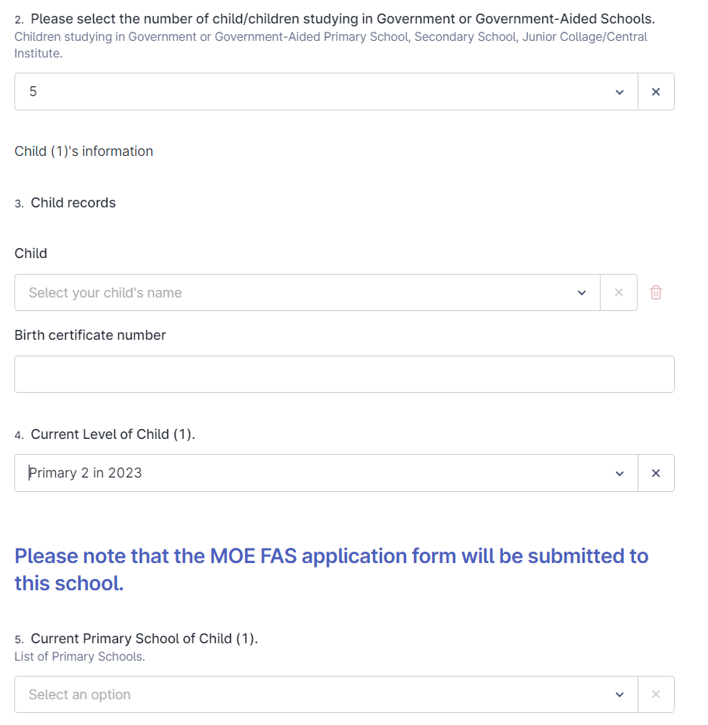
Drop list to select child’s name. BC/NRIC will be auto populated.

- Parent/ Legal guardian will still have to enter the information of older unmarried siblings who are 21 years old and above.
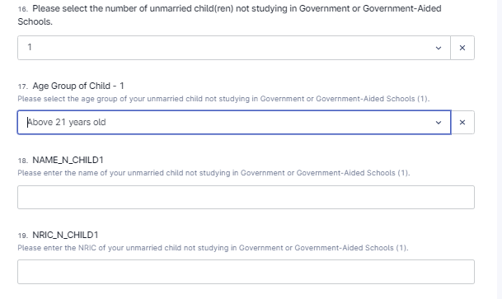

eFAS form Section I:

- Parent/Legal guardian enters particulars of child or children studying in GGAS.

- The eFAS form is designed to accept up to 6 children studying in GGAS. For family with more children in GGAS, the parent will need to use the hardcopy form instead.

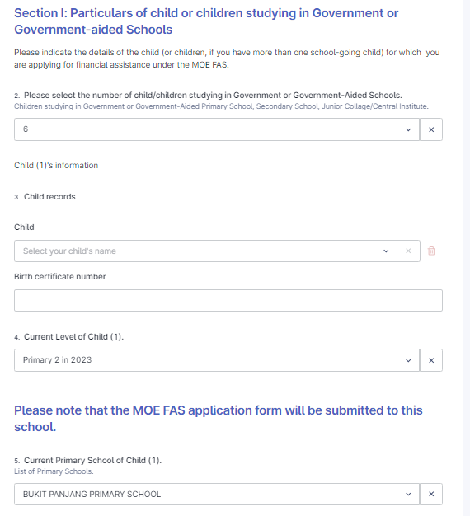
The eFAS application form will be emailed to the POCs of the school of the first child
Parent can enter up to 6 children studying in GGAS

eFAS form Section II:

- If any child is a resident of an approved welfare home, the Parent/Legal guardian can choose “Yes” and upload the letter from the approved welfare home approval supporting document in eFAS. The parent can skip the rest of Section II of the form.

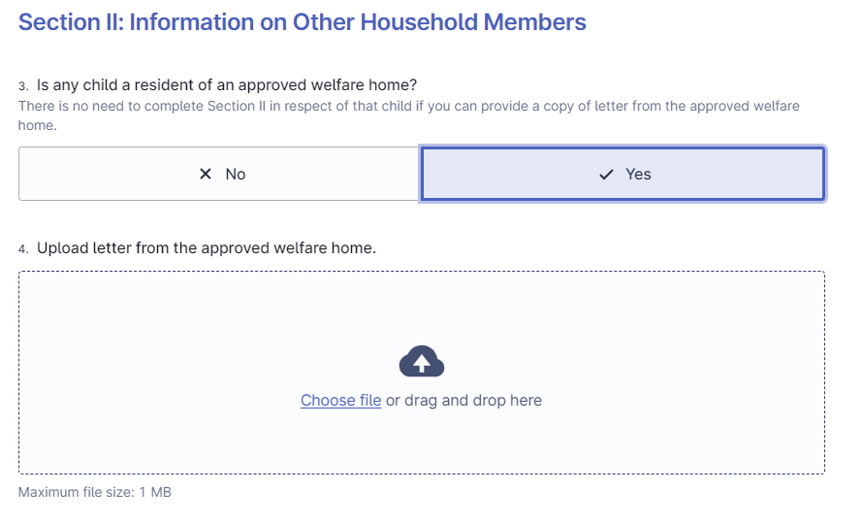

- Parent/Legal guardian provides email address and selects relationship with the child.

- The Parent/Legal Guardian will receive an email acknowledgement upon successful submission of the form.

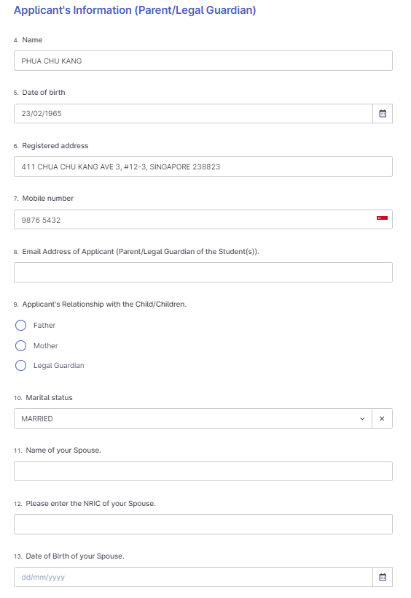
Select relationship.

- For families not on ComCare or the child is not in an approved welfare home, the parent/ legal guardian will be guided by the form to upload the required income supporting documents depending on his employment status.

- The form cannot be submitted if the required income documents are not uploaded.

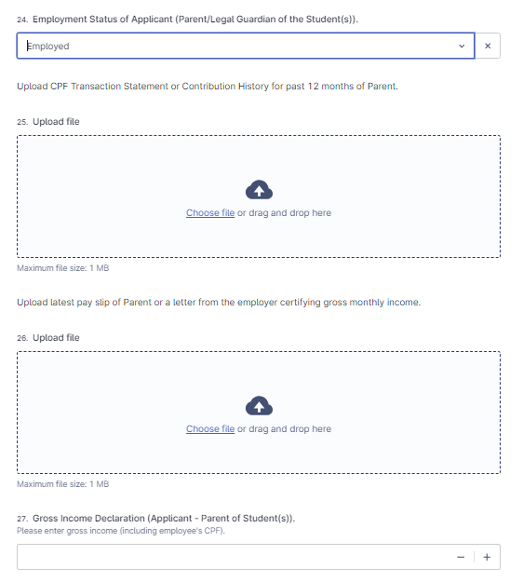
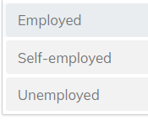

- Parent/ Legal guardian with “Married” marital status will be guided to provide the information of his spouse.
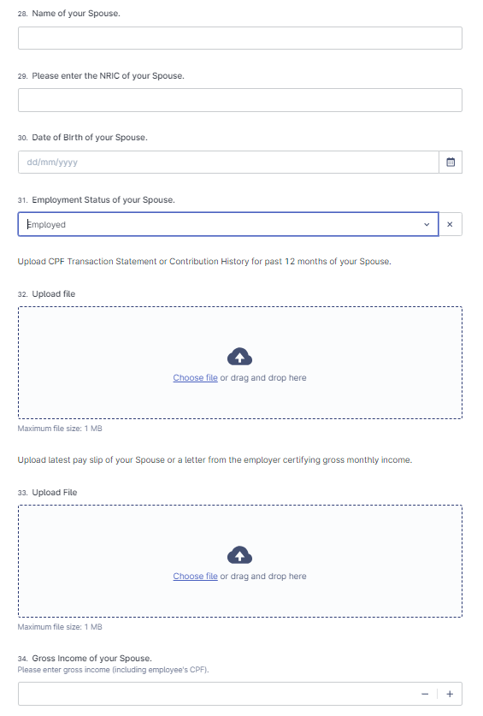

- Parent/ Legal guardian will be guided by the form to provide information of unmarried child/children (if any) not studying in GGAS and Grandparents (if any).

- The form is designed to accept up to 5 unmarried children not studying in GGAS.

- For unmarried sibling that is below 21 years old, parent/ legal guardian can select the child using the drop list.

- The name and NRIC of siblings age 21 and above will have to be entered by the parent/ legal guardian.

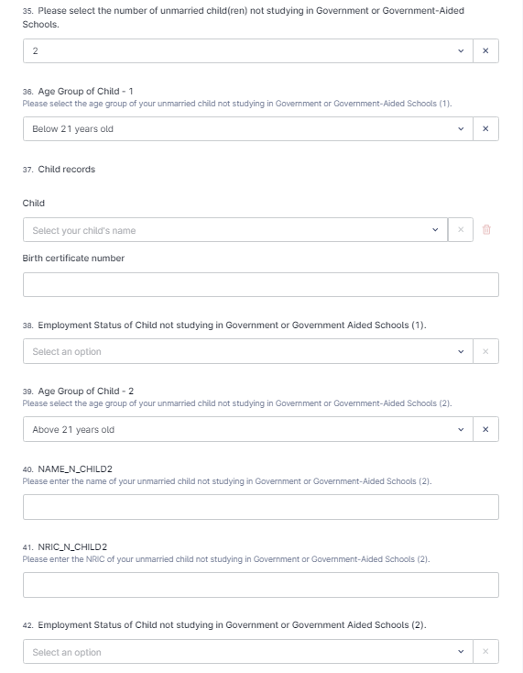
Age 21 and above Enter Name and NRIC manually.
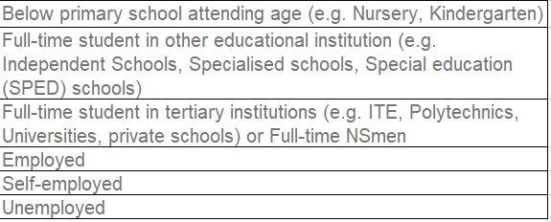
Below 21 years old Select child’s name from drop list.
Parent can enter up 0 to 5 unmarried children not studying in GGAS

- The form is designed to accept up to 3 grandparents staying with the student.

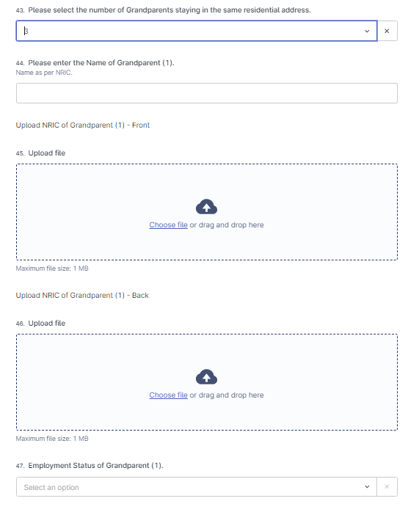
Upload front and back of NRIC (must show the address)
Parent can enter up 0 to 3 Grandparents
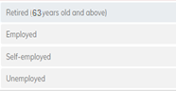

- Parent/ Legal guardian can declare other income (e.g. rental income) and total income of the household.

- Parent/ Legal guardian can also provide other relevant information or upload up to 5 additional supporting documents that can support his application (e.g. Loss of income or reduction in income document, Divorce document from the family court, etc).

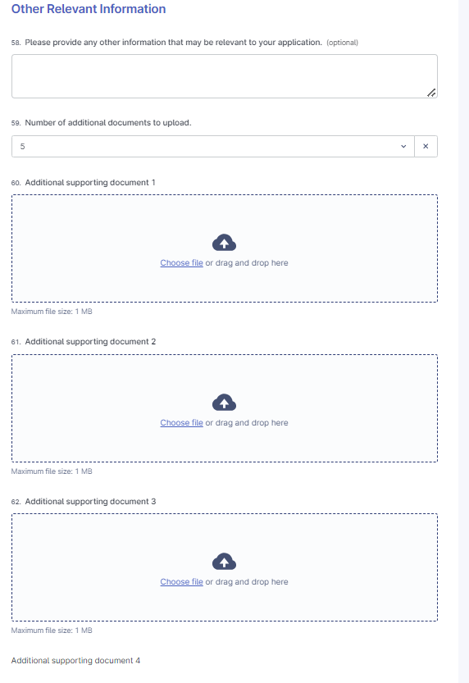
Option to upload up to 5 additional documents.

eFAS form Section III, IV & V: MOE FAS Benefits.

- Parent/ Legal guardian will be guided by the form to apply for transport subsidy and to refer to IMDA website for details on subsidised broadband and/or laptop/tablet under the IMDA’s digital access programme.

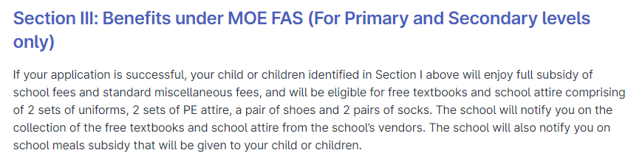
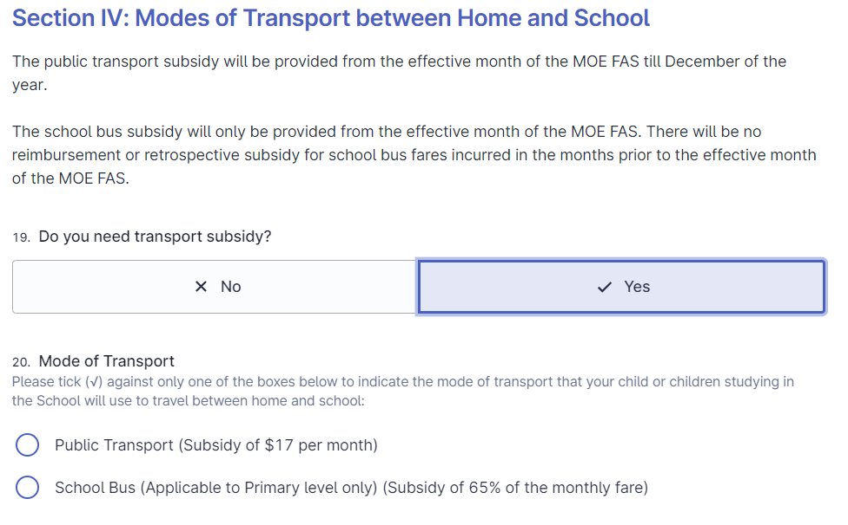
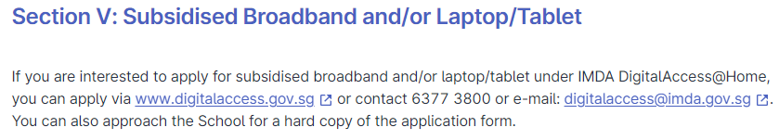

eFAS form Section VI:

- Finally, Parent/ Legal guardian must check the 2 boxes in this section to declare that the submission is true and to agree to the terms of the MOE FAS application.

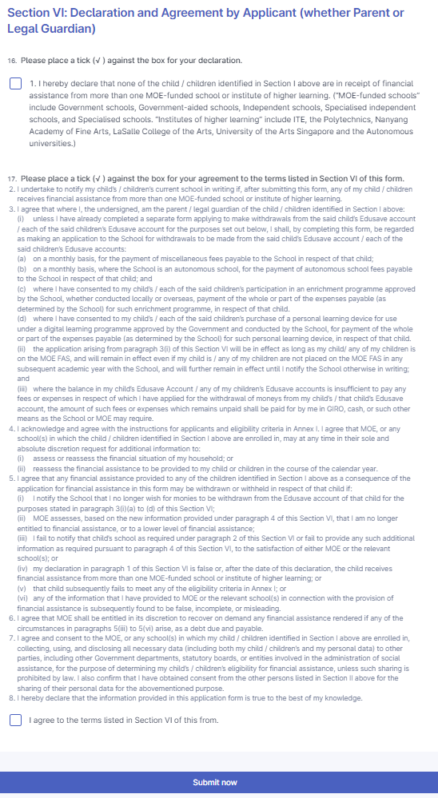

Acknowledgement Email to Parent/ Legal guardian (from Oct 2023)

- An acknowledgement email will also be sent to the Parent/ legal Guardian concurrently as shown below.
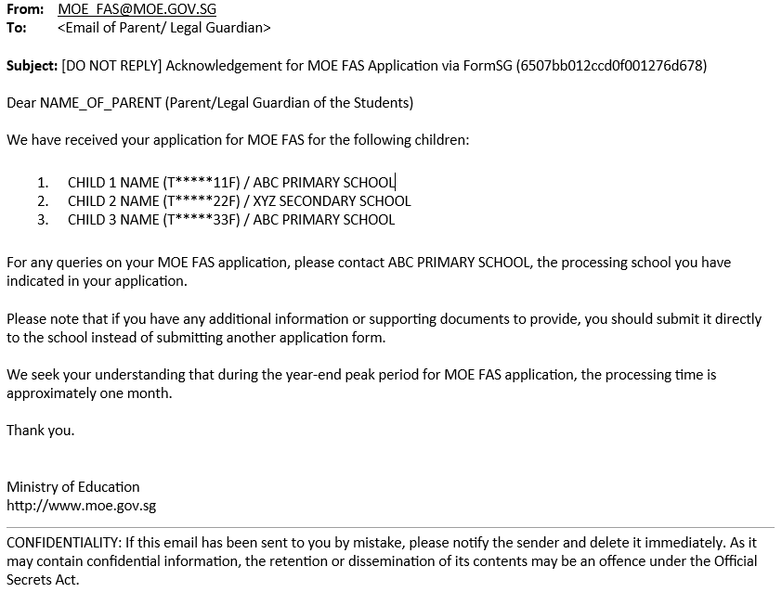

- This email serves as a reminder to the Parent/ Legal guardian:
- Which processing school have been selected;
- Parent should follow up with the processing school on the outcome of their application;
- Parent should submit additional documents to the processing school instead of submitting another eFAS application

