Default OPAC password for all patrons (Students and Teachers)
Please be advised the current password using NRIC will be changed to Moe@DDMMYYYY (DDMMYYYY is the DOB of the student) as a default password for all users. Upon login, all patrons are required to change the password under “My Account” page. The new password will have be made up of at least 12 characters and should contain characters from at least two of the following four categories:
i. Upper case (A through Z);
ii. Lower case (a through z);
iii. Digits (0-9);
iv. Special Characters (!, $, #, %, etc.).

Please see below the steps to change your password.
Step #1: Login
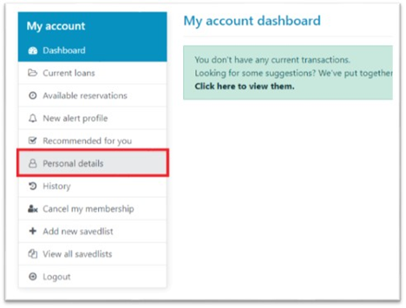
Step #2: My Account page
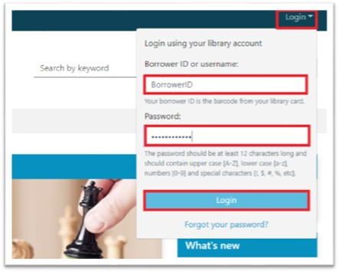

Step #3: Enter new password and confirm password
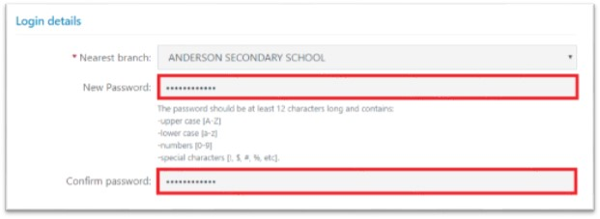
Step 4: Enter existing password and click Update
